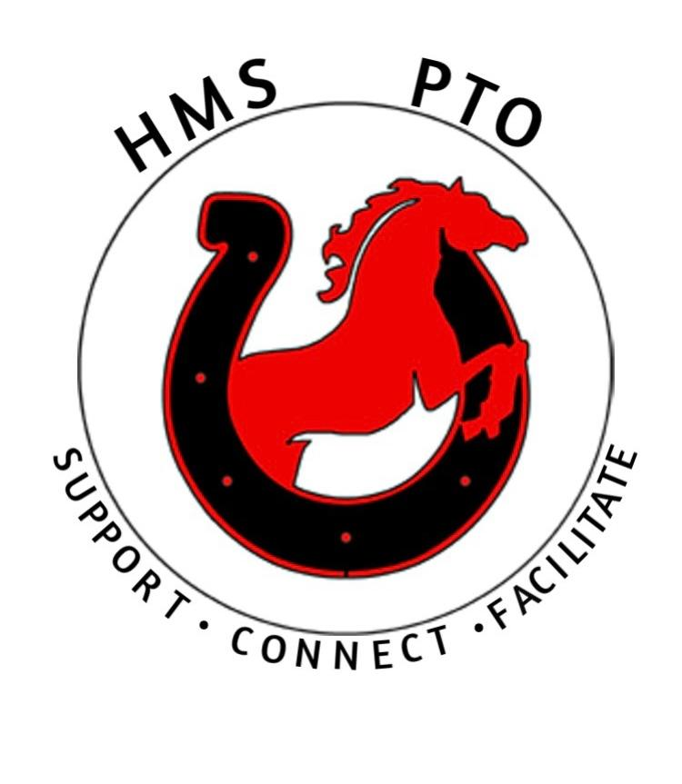

HMS PTO Meeting - Wednesday 11/18/2020 Zoom Call 7pm
Present at Meeting call: Susan Clement, Beth Sloat,
Keith Bowen, Marytrini Dominguez, Katie Verrocchio, Yojna Mathur,
Old Business:
~Vote done to accept notes from last meeting.
Treasurer’s Report:
~Balance at end of last meeting was $6,023.21 our new balance $4,858.21
Expenditures were for Student support backpacks $315.00 and Viral student viewing of Up- standards $850.00
~Sue worked with a CPA to complete paperwork on opening new PTO nonprofit account. Vote was made to spend the $25.00 to complete the Business ID requirements. Check and paperwork will be mailed to the State on Monday the Nov 23rd.
Vote Yes! was made that a text vote would be made if needed while Sue worked on paper work with CPA to organize new Account.
Vote was made to have 5 board members sign on Business ID account, 501-C3 and SS-4 account. Names to be on PTO Accounts are PTO President: Susan Clement, PTO Vice President: Dianne Chandonnet, Board member: Yojna Mather, Board Member Katie Verrocchio, Board Member: Marytrini Luna Dominguez.

~Only pending items for funds is T-shirts for the 8th graders, which are ordered in March.
Activity Update:
~ Scholastic Viral Bookfair was talked about starting on November 18th Dianne was not present at meeting and has not contacted the Beth Sloat about helping her. Sue asked Beth if she could look into starting the book fair. Possibly before the holidays.

~Soccer Donations Sue
Sue was asked if we could donate paper products to the HMS soccer team for use at their end of season party. Vote was taken and we will donate. The soccer party was unable to happen due to school Quarantine due to Covid. Coach is looking into another possible date.
~ PTO Facebook Art Contest Sue
Theme is the mission of the PTO: getting families, school and community together. Four winners will be selected for each season (Dec, Jan/Feb, Mar/Apr, May/June). Contest runs from 11/6-11/23. Each winner will receive an Adidas backpack with the school logo. Sue got confirmation from Keith backpacks were in his office. Sue and Marytrini will help with the voting on Monday Nov. 23rd and announcement of winners will be shared on Facebook and in school if student is in Person.

~Papa Gino’s Fundraiser
Yojna secured a date for the Papa Gino’s fundraiser unfortunately they only offer is Monday-Thursdays and only had 1 date available for December 7th 20% of dinner sales go to the school. Yojna mentioned that we could not do the fundraiser because they need a SS-4 Number of the organization. We currently do not have that status. Sue is going to meet on Friday with CPA to complete and submit the form and will get number to Yojna as soon as possible. A vote was made that we will be using funds raised by the event to offer more Viral educational videos / activities for students and families.
~Virtual Movie Night Sue
The movie Upstanders available to families for home viewing. We had some unsupportive feedback form parents. First that having one viewing time was too hard for students and families to attend. In addition, parents did not want their kids to have to any more work or zooming than was already required. The parents that did support the viewing, said making it a assignment made it easier to convince their child to watch it. Parents also said, good family conversations came out of the viewing. Everyone agreed that if we support a program like this in the future we should look for a program that has more viewing times offered.
~Hannaford Program Sue
Katie volunteered to continue the Hannaford pay our school program. Due to COVID-19 Hannaford is only offering a spring program.

New Business
Vote was made to approve adjustments to PTO By-laws to add
Article X. Dissolution Protocol

A. Upon the dissolution of the Hudson Memorial PTO all liquid assets raised will be given to Hudson Memorial Middle School.

Vote for New Members and Open Positions
President - Sue Clement Vice President - Dianne Chandonnet
Treasurer – OPEN
Board Member - OPEN Secretary – Katie Verrocchio,
Board Members: Marytrini L, Yojna Mathur, Megan Grand
Next meeting – December 16th 2020 7:00 zoom meeting

