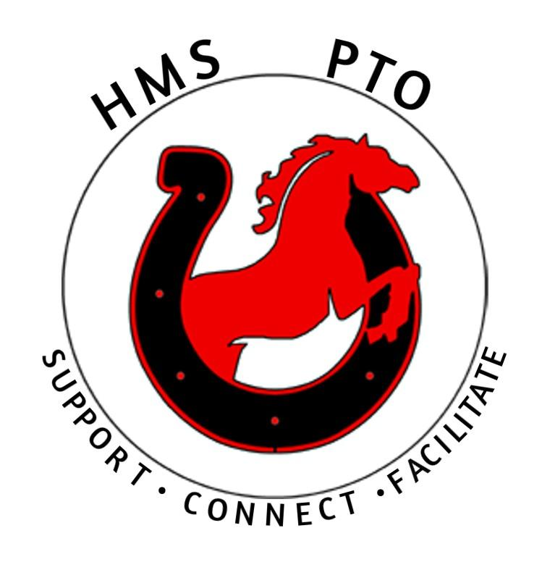

HMS PTO notes February 2021
Account balance $4,693 there was a reimbursement to Sue for $275 for the 5013c also a deposit for $825 from the Hannaford helps program.

· Diane dropped off the Hershey kisses at the school for a small valentine’s day gesture to the staff they were all appreciative. Thanks Diane!

· Bookfair: Sarah updated us that the department heads can fill a cart and we can divvy it up between the Language Arts departments to use our scholastic credit. She agreed to stay on top of them to make sure we get the books ordered in a timely manner, so we don’t lose the credit. We mentioned the idea of an outdoor book fair but after discussion decided logistically it wouldn’t work out. Thanks Sarah!

· 8th grade t-shirt update: Sue talked to Tom he said 4 weeks’ notice is very safe if we get the t-shirt sizes by the week of 4/5 that gives plenty of time.

· Teacher appreciation week update: Teacher Appreciation week will be May 3rd-7th the week we get back from April break. At our last meeting Megan had discussed daily theme covid friendly ideas we are going to do, in addition to that Sue offered to make a slide show, Mr Bowen said the posters and signs from last year are still at the school and could be reused. If anyone wanted to make new ones they could be dropped off at the school. Discussed maybe doing some sort of a teacher give away now that we are a 5013c we can seek donations.

· Rocco’s fundraiser update: Yojna spoke to Roccos and secured Thursday March 25th for our fundraiser date. Rocco’s will allow us to receive profit all day (11-9) as long as customers show a flyer. We will receive 15% of delivery and 20% of dine in or take out. Mr. Bowen offered to pick up lunch if any staff members want to order that day, Yojna was going to check with Rocco’s to see if we could call in the staff order the day before so it would be ready for early lunch pick up. Thanks, Yojna!

· Hannaford Helps update: Katie spoke to Hannaford they haven’t heard anything about the Hannaford helps program starting up yet but said it is typically running in spring and to keep calling back checking.

· Adidas backpack giveaway ideas: We have 4 left to give away the ideas we decided to go with are:
1) 8th grade year book cover winner
2) Poetry contest 1 winner from each grade. April is poetry month Joy Whitaker & Beth Sloat have kindly offered to draft something up Mr. Bowen suggested using a copy of the inauguration poem as a headline with what can you do? Instagram post Mr. Bowen said we have a good following there.
· Outdoor movie night update: Mr. Bowen suggested we not rule it out yet. If We are able to do it, we may need to consider two nights for each cohort outside w/mask spaced apart, with Mr. Russell’s approval. Another Idea was to have a Ice-cream social, distribute ice cream from café as it is prepackaged. DQ gift cards for RLA students.

Next meeting Wednesday March 17th 7:00pm

